Ed White Middle School Speech and Theatre Team Handbook
Please keep this book handy to answer all your questions on policies relating to this AFTER SCHOOL PROGRAM through the Theatre Arts Department!

Dear Parents and Students,

Hello. My name is Adam Fellers, and welcome to Ed White Middle School and our wonderful Theatre Arts Department. I cannot tell you how excited I am about this year, and all the new and wonderful changes that are in store. I am fully committed towards every child’s continued academic growth and newfound appreciation in the Arts. Learning and growing is my purpose, and I will foster it by keeping it my highest priority while providing a safe and healthy environment for all my students.

In hard economic times, three things are true: education is vital to our children’s and community’s future, partnership between school employees, parents, community, business volunteers, and children is more important than ever, and Fine Arts defines who we are as a community. We are a strong program thanks to our history of teamwork, but I would like make sure that none of these three truths slip through the cracks.

This Student/Parent Handbook provides important information about our program's policies and procedures. Please read it carefully and keep it available. If you have any questions, I will be happy to assist you. I can be reached by calling 356-5900 ext. 65958, or through email at afelle@neisd.net. Please check out my website for further details. The web address is www.eagletheatrecompany.com

Thank you for entrusting your child to me. I look forward to another wildly fun and successful year.

Adam Fellers
Theatre Arts and Broadcast Journalism Director

Bio for Mr. Fellers. (Ed White Middle School Teacher of the Year 2010-2011 and PTA Lifetime Member Award 2010-2011):

Graduate of Texas State University… Received teaching certificate in Theatre Arts 6-12 through a nationally ranked program at Region XIII in Austin… Just finished 10th year of teaching and 8th year as Director of Theatre Arts at Ed White Middle School… Started WMSN Channel 6 at Ed White which broadcasts the Morning Announcements to the entire faculty/staff and student body... Baritone with 40+ stage credits to date… Some of these include Driving Miss. Daisy (Boolie Werthan), Into the Woods (The Baker), The Sound of Music (Max Detweiler), Forever Plaid (Smudge), Twilight of the Golds (Walter Gold), Lend Me a Tenor (Mr. Saunders) ATAC Globe Nominee for Best Comedic Actor, Little Shop of Horrors (Voice of The Plant), Lucky Stiff (Vinnie Di Ruzzio), Seussical the Musical (Horton the Elephant), The Producers (Max Bialystock), and Oliver! (Mr. Bumble)… Former Board Member and Vice President of both The Greater New Braunfels Arts Council and Circle Arts Theatre. Currently serves as a City Commissioner for the Commission for the Arts for the City of New Braunfels.

Table of Contents
Important Dates………………………………………………………………….…….…3
Classroom Rules and Regulations……………………..............................4
Speech and Theatre Team Syllabus……………………………………………..6
Missing a Contest/Performance Policy/Mr. Fellers’ Pet Peeves……9
Contracts and Agreements….…………………………………………………….10
- Behavior Contract for Theatre Arts/Theatre Arts Pledge for Students and Parents………………………………………………………..10
- Expectations for Theatre…………………………………………………..11
- Ed White School Production Policies and Rehearsal Rules Contract……………………………………………………………………………12
- NEISD Fine Arts Code of Conduct…………………………………..….13
- Student Release Form……………………..………………………………..16
- Student Handbook Verification Form………………………………..17
  - Page 17 will need to be signed and returned to the teacher. You will keep pages 1-16 at home for your reference.

Important Dates to Remember

Semester 1
Event Date Location
Fall Play Production October 24th White Middle School
Advanced Theatre 6:00-6:30

Fall Speech/Theatre Festival December 10th Lopez Middle School
Speech/Theatre Team (Afterschool) 8:00-5:30

Winter Play Production December 19th White Middle School
Beginning and Intermediate Theatre 6:00-8:00

Semester 2
Event Date Location
UIL One Act Play February 24th Nimitz Middle School
Advanced Theatre 12:00-9:30

Spring Speech/Theatre Festival April 22nd Harris Middle School
Speech/Theatre Team (Afterschool) 8:00-5:30

Spring Play Production April 24th White Middle School Beginning and Intermediate Theatre 6:00-8:00

Summer Play Production May 29th White Middle School Advanced Theatre 6:00-6:30

Theatre Arts Ceremony May 29th White Middle School Advanced, Beginning, and 5:30-6:30
Intermediate Theatre

Classroom Rules and Regulations
These rules apply even after school
Rule #1: RESPECT this taxpayer funded facility.

‐  ‐  ‐ | Clean up your trash  NO food, gum, or drink (Bottled water is fine)  NO jumping over the wall | ‐  ‐ | NO feet up on the chairs or sitting on tables  NO graffiti or drawing on any of the surfaces
Rule #2: RESPECT each other.

This is a safe space where people can express themselves and take a risk by exposing themselves up there on stage. We show respect for each other in a couple of ways. . . .
‐ APPLAUSE! Always clap for your classmates performances, no matter how they do!
‐ No judgment! I’m the one that grades the performers, not you! Support your classmates by telling them they did a good job in their performance.
‐ No swearing! Respect other people’s ears by not swearing in the classroom.
‐ You will use words such as “Yes, sir” or “No, sir” as well as “Please”, “Thank you” & “You’re Welcome”
Any inappropriate comments made towards your fellow classmates will result in an automatic referral.

Rule #3: RESPECT the craft of Theatre Arts.

Theatre is a discipline. Without a strong foundation, a house can and will fall down over time. Discipline is the foundation of any organization whether its Fine Arts or Athletics. You do not honor the craft or the many people who pour countless hours into it, if you do not honor or respect Theatre Arts. You will need an open mind as we go into a world the likes you have never seen.

Rule #4: Always, always. Always, follow the 5 P’s.

- Prompt: ready, on time, or quick to act.
- Prepared: willing and able to do something.
- Polite: showing or having good manners or common courtesy.
- Productive: producing satisfactory or useful results.
- Personable: having a pleasant personality and appearance.

Rule #5: Attend to personal needs before coming to rehearsal.

I have been instructed not to give passes to lockers and to limit passes. Students with doctors’ excuses are the exception to the rule. Do not forget about the school district’s 10\10 Policy.

Rule #6: No electronic equipment of any kind.

I realize it’s after school, but you cannot work or rehearse if you are on the phone constantly.

Rule #7: Follow any others rules as written in “The NEISD Student Handbook” and “The Student Fine Arts Code of Conduct”.

Zero Tolerance Behavior

- Cussing at the teacher or other students.
- Telling the teacher or other students to repeatedly shut-up.
- Bullying and or fighting.
- Any form or harassment of the teacher or students.
- Talking back
- Not doing your work.

I have a zero tolerance policy for things of this nature. This is a Theatre Arts class, so there are all kinds of folks in the Theatre. We are all here to learn and grow. Theatre Arts is like athletics in that we work and play as a team.

If you do any of the above things, I will automatically call home. Those behaviors will not be tolerated either in Fine Arts classes or Athletics.

Why do we have these rules? Why is it so important?

  - People have different learning habits, and cannot learn in a crazy noisy environment.
  - Safety reasons. Some students leave their desks and harass other students, or blurt out put downs. That will not happen here.
  - It’s just COMMON COURTESY, and a sign RESPECT-- No one wants to work in a negative environment.
  - Studies show that a classroom that is more structured increases student success.
  - The District is my boss, and I will follow the rules set by my bosses. They have allowed me to set even higher standards and rules due to this being an elective course.
  - Many people with degrees or a lot of life experience have sat down and studied and researched these rules to help you become more successful in the classroom and the workforce.

SPEECH AND THEATRE TEAM Syllabus
Memorization is a requirement; therefore work both here and at home. In this class we will be preparing students for the UIL Speech and Theatre Festival in the Fall and Spring (December 10th and April 22nd). Students are required to enter into three events per semester.
• Semester One Students will attend the Fall Festival: December 10th, 2016 (Saturday)
• Semester Two will attend the Spring Festival: April 22nd, 2017 (Saturday)

NEISD Speech and Theatre Festival

General Entry Rules

    - Students may only enter 1 event in sections A and B. A student may enter 2 of the 3 events in section C.
    - Schools are limited to 25 entries in duet acting and 30 entries in all individual events. Additional students may be waitlisted.
    - Sixth graders are allowed to do non-memorized events only. Seventh and Eighth graders must do one memorized event to compete.
    - Awards will be based on the cumulative ranks of two rounds (except for group events.) A student must perform in both rounds in order to be eligible for an award. No ranks will be doubled.
    - Most events will have a 30 second grace period. “Grace" is an extra 30 seconds to conclude a performance that will not be considered overtime. A contestant will demoted one rank by the tab room staff when overtime and method of timing is confirmed with the judge
    - There is a 3.00 entry fee each event. Each member of a duet team will be charged an entry fee of 3.00. All entries fees must be paid to the teacher before the entry deadline.
    - A concessions stand will be available for students to purchase food and beverage.

Division of Events

Section A: Prose or Humorous Interpretation

Section B: Duet Acting or Dramatic Interpretation

Section C: Impromptu or Poetry

Saturday on December 10th and April 22nd

8:00 – 9:30 Section A Rd. 1
9:30 – 11:00 Section B Rd. 1
11:00 – 12:30 Section C Rd 1
12:30 – 2:00 Section A Rd. 2
2:00 – 3:30 Section B Rd 2
3:30 – 5:00 Section C Rd. 2
Awards starting between 5:30 and 6:00

Awards

Students will be ranked first through fifth in all speech events. Fifth place being the lowest rank regardless of the number of competitors in section. No ties will be allowed for the first four ranks. Awards will be based on the cumulative total of ranks from the two rounds, or in the case of group events, the rank value of the round.

WE NEED JUDGES

Volunteers are needed for judging events. Each campus is REQUIRED to provide a certain number of judges. If you are interested, please fill out the information provided on page 17 of this handbook.

Participation Requirements for Speech & Theatre Contest

Students should make plans to stay for the entire competition on the two Saturdays on December and April. Part of the learning experience is seeing other students perform so all competitors should remain in their assigned room for all presentations. Parents are invited and encouraged to attend and volunteer in some capacity but also to observe their child in competition however video recording and/or photography during rounds is not allowed!

All competitors must attend all “Team Rehearsals” from 3:35-4:45 every Tuesday and Thursday Frequent rehearsal ensures a beneficial learning experience and quality performance. Memorization of material for certain events is required and takes time. Partner events require coordination among the members to attend the same rehearsals. In short, preparing for Speech & Theatre contest is a lengthy process that requires dedication and determination. Anyone neglecting their responsibilities to the team will be removed. If a rehearsal has been canceled, I will contact you either via text message or email.

Clothing

As a member of this team you are representing the Theatre department and Ed White Middle School. You are expected to act and dress accordingly. A dress, skirt and blouse, or a nice pantsuit for the ladies and dress pants and collared shirt/tie or suit/tie for the gentlemen will create an atmosphere of a special event, which this most certainly is. Dress shoes are required as well, no gym shoes or flip flops! Jeans, shorts, and/or t-shirts are not allowed! Please consider the amount of action in your events when dressing for the contest. Comfort and safety should outweigh fashion!

Event Descriptions

Section A Events

Prose

- Time limit: 6 minutes maximum. (30 second grace)
- Introduction: is memorized, gives the title and author, and includes an attention getter to draw the audience into the presentation.
- Selection: must be read from a manuscript, not a book. It must be published, have merit and correspond with the student’s level and ability. NO ORIGINAL WORKS.
- Presentation style: Acting is discouraged but character voices may be used.
- No props, costumes, or chairs may be used.

Humorous Interpretation

- Time limit: 10 minutes maximum. (30 second grace)
- Selection: is humorous in nature. The material is from published works. It may be adapted from a play, novel, poem, story, children’s book, etc. NO ORIGINAL WORKS. The scene may involve more than one character.
- Introduction: is memorized, gives the title and author, and includes an attention getter to draw the audience into the presentation.
- Memorization: is required; prompting or scripts are not allowed.
- No props, costumes, or chairs may be used.

Section B Events
Dramatic Interpretation
- Time limit: 10 minutes maximum. (30 second grace)
- Selection: is serious in nature. The material is from published works. It may be adapted from a play, novel, poem, story, children’s book, etc. NO ORIGINAL WORKS. The scene may involve more than one character.
- Introduction: is memorized, gives the title and author, and includes an attention getter to draw the audience into the presentation.
- Memorization: is required; prompting or scripts are not allowed.
- No props, costumes, or chairs may be used.

Duet Acting

- Time limit: 10 minutes maximum. (30 second grace)
- Group: 2 members, with roles as equal as possible.
- Introduction: is memorized, gives the title and author, and prepares the audience for the presentation.
- Material: must be taken from published works. It may be taken from a play or adapted from a novel, poem, story, children’s book, etc. NO ORIGINAL WORKS.
- Memorization: is required; prompting or scripts are not allowed.
- No props or costumes. 2 chairs may be used for the performance.

Section C Events

Impromptu

- Time limit: 5 minutes maximum. (no grace)
- Draw: Each contestant will draw 3 topics, select one, and have 3 minutes to prepare a speech.
- Topics: may be serious or humorous in nature, will be designed to include subjects that are familiar to the student.
- Notes: Blank paper may be used to organize ideas during preparation; however, notes may not be used during the speech. Contestants may remain in the contest room.
- Presentation: Judges should be instructed to use the following criteria in ranking the contestants: effectiveness of delivery; organization of ideas; and overall impression of the speech.

Poetry

- Time limit: 6 minutes maximum. (30 second grace)
- Introduction: is memorized, gives the title and author, and includes an attention getter to draw the audience into the presentation.
- Selection: must be read from a manuscript, not a book. It must be published, have merit and correspond with the student’s level and ability. NO ORIGINAL WORKS.
- Presentation style: Acting is discouraged but character voices may be used.
- No props, costumes, or chairs may be used.

Missing a Contest/Performance Policy
(This policy is the same for Beginning, Intermediate, and Advanced Theatre Arts)
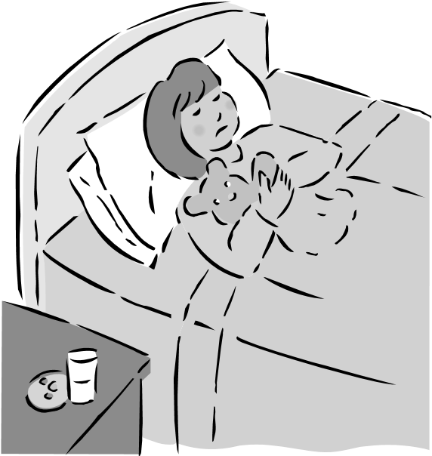
Things happen. Students get sick. I understand. However, if you are absent on a contest/performance day, there is a specific procedure that must be followed. If a student has an excused absence on the day of a performance, he or she must first clear the absence with me THAT DAY.
An e‐mail, text, or telephone call from the parent must happen THE MORNING OF THE CONTEST/PEROFRMANCE. We will need to inform the school Principal, Fine Arts Department Head, and parents of other students that we need to reschedule the show. We will need to inform the district as well. Then I need to sit down with the Principal and Department Head in order to see when we can reschedule our show. I want you to understand thought that the first rule in Theatre is, “The Show Must Go On!” Here is a list of reasons that I will not find acceptable when calling in during a performance date…
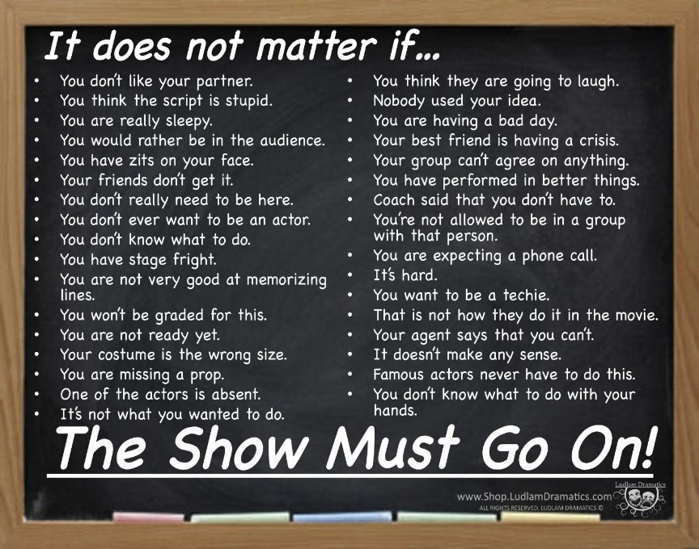
Mr. Fellers’ Pet Peeves
Mr. Fellers has a few pet peeves! Don’t do these!

1. Not working when given rehearsal time
Guess what I want you to do when you are given time to work in class. . . .REHEARSE! It’s not social hour. It’s work time!

2. Being absent all the time
Being absent constantly keeps you and us from mounting a show that we and the community can all be proud of. If you are contagious, then please, by all means stay home. We don’t want to spread anything around campus. If you are staying home because you stayed up late and didn’t get enough sleep, that’s no excuse. Make sure to get a full 8 hours of sleep. Death in the family? Those are difficult and hard times, and completely understandable. If you have a vacation planned and will be out of town for a week or more, you need to inform me ahead of time.

3. A negative attitude and not having an open mind
Give new things a chance in this class. Make the most out of every opportunity you are given. If you can’t commit, then quit!

4. Not following through for your group members
If you say you are going to do something, then do it. If you are going to commit to this Department, then I want 100% and nothing less!
It’s rude and unprofessional if you don’t. Save the private life for later.

Contracts and Agreements
Behavioral Contract for Theatre Arts/Broadcast Journalism
By remaining in the class and not getting a schedule change, the student agrees to be on his/her best behavior and have a good attitude while in Theatre Arts or any Elective. The student agrees to follow every instruction that the teacher gives them without unnecessarily questioning the teacher's authority, or complaining while the teacher is trying to run a smooth class. In case the student is unable to fulfill the instructions of the teacher which are for the good of the student, then the teacher has the right to give them further consequences.
The student is further reminded of the Student Code of Conduct concerning their participation in ANY Elective…
“EXTRACURRICULAR ACTIVITIES”

The opportunity to participate in extracurricular activities is a privilege extended to all students of NEISD. Participation in extracurricular activities places students in a position of recognition and often bestows the position of role model upon the student participants. Students who elect to accept the privilege of participating in extracurricular activities must recognize that they are a representative of the school and District, and will be held to a higher standard of conduct than that applied to other students. This applies to both school related and non-school related activities.”
If the student was placed in the class without any choice in the matter, the student is being reminded again that they are still held to all the expectations and standards set forth in the class. The student was informed at the beginning of the semester that if the class was not for them, that they needed to get a schedule change. It is not the responsibility of the teacher to do that for them.
Theatre Arts/Broadcast Journalism Pledge for
Students and Parents
I pledge the following:

- I will be a team player: My role is important to the class and it is important to me. Just as I want my ideas heard and worked with by my teammates, I will listen to them and support their ideas in a POSITIVE way. I will NOT any anyway bring a negative attitude, or use negative words towards my fellow teammates.

- I will be flexible and open-minded: I will do my best to put aside my insecurities to take advantage of ALL of the opportunities that are given to me to improve myself so as to become a better citizen for my community, state, country, and the world.

- I will be both focused and energetic: It may seem like focus and energy are opposites, but sports teams (for example) use focused energy all the time. I can be focused without being low-energy, and I can be energetic without bouncing off the walls!

- Please, No Pickles: Please know that tardiness, absences, and not learning lines leave the class in a PICKLE. We work as a team (an ensemble) and if one of our team members is missing or behind on lines, our progress is challenged! I will be on time and prepared for anything that comes my way in class.

EXPECTATIONS FOR THEATRE ARTS
BROADCAST JOUNALISM

What I Expect From My Students

I expect the following things:

1. To get an education and not be a disruption in ALL my classes.
2. Pass every class.
3. To hustle 100% at all times.
4. To give unselfish love towards your classmates and to respect them. Before you can love and respect somebody else, you must love and respect yourself.
5. Practice to the best of your ability.
6. To be totally honest in all your dealings.
7. To be extremely loyal to your school, administration, teammates, coaches, families and friends.
8. To work hard to the maximum, of your potential at all times, practice and games. This includes sprints.
9. To be prompt for all meetings and practices.
10. Never take an opportunity to criticize and never pass up one to praise.
11. To be a part of something great.
12. To be a winner and a leader for our campus.

What You Can Expect From Me the Teacher

You can expect the following things:

1. To be loyal to you in all areas.
2. To be totally honest.
3. To provide the leadership and training necessary to achieve our goals.
4. To work you harder than you have ever worked before.
5. To assist you in any way possible now and after you graduate.
6. To treat you with respect as you do me.
7. To make all decisions predicated on what is best for the team and then what is best for the individual.
8. To do everything within our power to improve our facilities and make this the best place in Texas to go to school and learn Theatre.
9. To help you mature and grow as a person.
10. To help you reach your goals.

Rehearsal Policies and Rules Contract

Rehearsal Rules

- BRING YOUR SCRIPT AND A PENCIL TO EVERY REHEARSAL!

- ALWAYS be on time. If there is a good reason you can’t be, let the DIRECTOR know before rehearsal, so we can adjust our plans. You must also inform the DIRECTOR when you have to leave early before rehearsal begins. Otherwise, you will be expected to stay until rehearsal time is over.

- If you are ABSENT WITHOUT PERMISSION TWICE, you’ll be dismissed from the show. The absence must be excused by the director.

- We conduct CLOSED rehearsals. This means that your friends or parents cannot hang out while we practice. NO ONE may visit without prior permission.

- DO NOT leave the theatre FOR ANY REASON without asking the DIRECTOR.

- Use any waiting time to study lines or to develop your character.

- Be courteous to those rehearsing around you. This is not a time to socialize!

- DO NOT talk whenever the Director is speaking. Besides distracting others, YOU may miss something you need to know.

- Cell phones or electronic devices are not allowed during rehearsal unless you have special permission from the DIRECTOR.

- You will help keep every space that we used cleaned after we are done.

Failure to follow any or all of the above policies or rules can result in a student being replaced. The contract must be signed and turned in before a student can accept a role. Failure to sign and turn in the contract means the role will be offered to another student. You must agree to all of the terms of the contract in order to participate in a production.

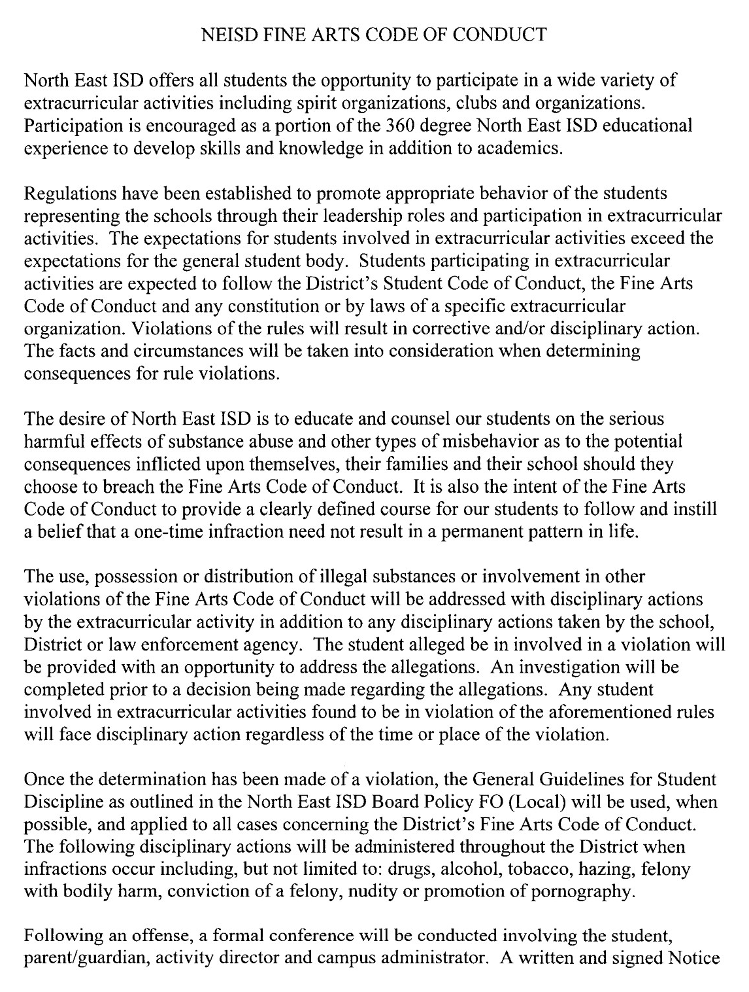
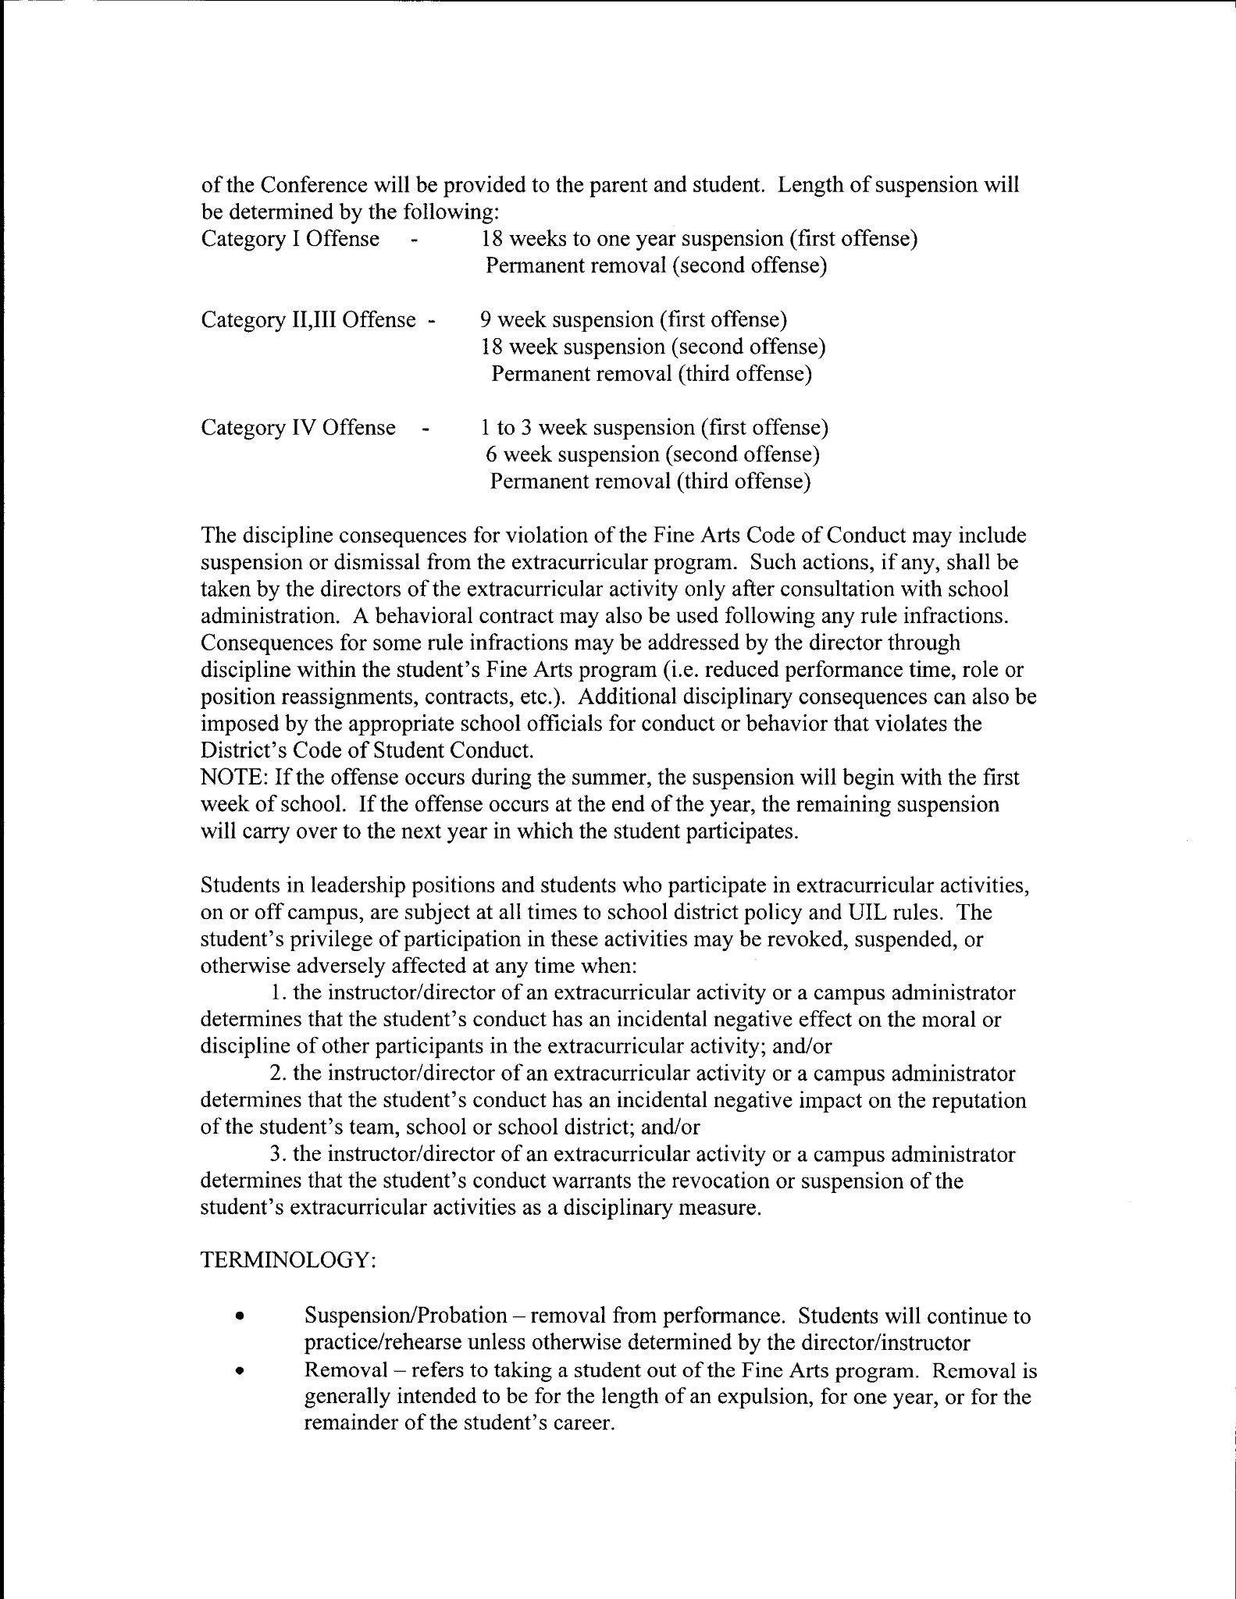
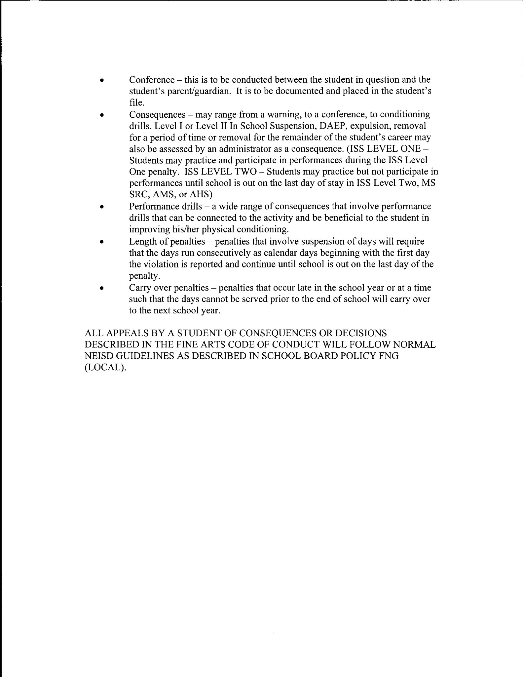

I reserve the right to alter the syllabus for this class should it be necessary. Any changes will be fully explained to the parents and students.

Student Handbook VERIFICATION Form

I have read and reviewed the following (Please check off each box to double check)…

- Theatre Arts/Broadcast Journalism Student/Parent Handbook (pages 1-9)
- Behavioral Contract for Theatre Arts/Broadcast Journalism/Theatre Arts/Broadcast Journalism Pledge for Students and Parents (page 10)
- EXPECTATIONS FOR THEATRE ARTS/BROADCAST JOUNALISM (page 11)
- Production Policies and Rehearsal Rules Contract (page 12)
- NEISD Fine Arts Code of Conduct Student (pages 13-15)

I understand the expectations and rules for the Theatre Arts Department, Ed White, and NEISD. Our signatures indicate that we have reviewed and discussed the handbook together, that we will commit and support the Ed White Middle School Theatre Arts Program, and do what is necessary to insure the success of the Theatre Arts Department. We are also aware that positive and proactive behavior is a MUST for our program and school and agree to back-up all efforts to keep our school and department safe and orderly. I understand that I/my child will be responsible or adhering to the rules and procedures as outlined in this document. I am aware of the responsibility for reading and understanding the contents of the document.

Student Name (please print) ___________________________________________________________Grade _____________

School ____________________________________________________________________ Date________________________

Student Signature ______________________________________________________________________________________

Parent/Guardian Signature ______________________________________________________________________________
---------------------------------------------------------------------------------------------------------------------------------------
- Student Media Release Form (page 16)

Student Name (please print) ___________________________________________________________Grade _____________

_____ Has my permission
_____ Does not have my permission

To be interviewed, photographed, and/or filmed for public information for us in the news media or professional education information.

School ________________________________Teachers Name Adam Fellers Theatre Arts Director Date__________________

Address _______________________________________________________________________________________________

Parent/Guardian Signature _________________________________________________________________________________

Comments:

---------------------------------------------------------------------------------------------------------------------------------------
- Contest Judge Volunteer Form
Name___________________________________________ Phone___________________ Email_____________________
I can judge during the following times…
_____ All day 7:45-4:30 _____ Morning only 7:45-12:00 _____ Afternoon only 12:15-4:30

