Ed White Middle School
Theatre Arts Handbook
Please keep this book handy to answer all your questions on policies relating to class and the Theatre Arts Department!
Dear Parents and Students,
Hello. My name is Adam Fellers, and welcome to Ed White Middle School and our outstanding Theatre Arts Department. I cannot tell you how excited I am about this year and all the new and beautiful changes that are in store. I am committed to every child's continued academic growth and newfound appreciation in the Arts. Learning and growing is my purpose, and I will foster it by keeping it my highest priority while providing a safe and healthy environment for all my students.
In challenging economic times, three things are true: education is vital to our children’s and community’s future; the partnership between school employees, parents, community, business volunteers, and children is more important than ever, and Fine Arts defines who we are as a community. We are a strong program thanks to our history of teamwork, but I would like to make sure that none of these three truths slip through the cracks.
This Student/Parent Handbook provides essential information about our program's policies and procedures. Please read it carefully and keep it available. If you have any questions, I will be happy to assist you. I can be reached by calling my office at (210) 356-5958, text at (210) 920-0136, or through email at afelle@neisd.net. Please check out my website for further details.
Thank you for entrusting your child to me. I look forward to another wildly fun and successful year.
Adam Fellers
Theatre Arts Director
Bio for Mr. Fellers. (Ed White Middle School Teacher of the Year 2010-2011 and PTA Lifetime Member Award 2010-2011):
Graduate of Texas State University… Received teaching certificate in Theatre Arts 6-12 through a nationally ranked program at Region XIII in Austin… Just finished my 15th year of teaching and 13th year as Director of Theatre Arts at Ed White Middle School… Started WMSN Channel 6 at Ed White, which broadcasted the morning announcements to the entire faculty/staff and student body... Baritone with 40+ stage credits to date… Some of these include Driving Miss. Daisy (Boolie Werthan), Into the Woods (The Baker), The Sound of Music (Max Detweiler), Forever Plaid (Smudge), Twilight of the Golds (Walter Gold), Lend Me a Tenor (Mr. Saunders) ATAC Globe Nominee for Best Comedic Actor, Little Shop of Horrors (Voice of The Plant), Lucky Stiff (Vinnie Di Ruzzio), Seussical the Musical (Horton the Elephant), The Producers (Max Bialystock), and Oliver! (Mr. Bumble)… Former Board Member and Vice President of both The Greater New Braunfels Arts Council and Circle Arts Theatre. Currently serves as a City Commissioner for the Commission for the Arts for the City of New Braunfels.

Table of Contents
Important Dates…………………………………………...…….…3 Classroom Expectations Guiding Principles………………............4 Play Report Requirements and Forms…………………………….7 Theatre Biography Requirements and Forms…………………………………………………………….12 Theatre Arts Department Course Descriptions and
Requirements………………….…………….………...….……...15 Grading Policy for Theatre Arts…………………………………17 Missing a Performance Policy/ Mr. Fellers’ Pet Peeves ………..18 Contracts and Agreements
o Behavior Contract for Theatre Arts/ Theatre Arts Pledge for Students and Parents ...…………………..……….……19
o Theatre Arts Promise for Students, Parents, and Teacher…………………………………………..………....20
o Production Policies and Rehearsal Expectations Contract……………………………………………….……21
o Permission to View Films/Videos for Theatre Arts……...………………………………………...….…….22
o NEISD Fine Arts Code of Conduct……………….… ….23
o Student Release Form……………………..……………..28
o Student Handbook Verification Form………………..…..29
o Page 29 will need to be signed and returned to the teacher. You will keep pages 1-28 at home for your reference.

Important Dates to Remember
Semester 1
A Night of Prose and Poetry (Beginning Theatre I)
Location: Courtyard Theatre
Date: September Time: TBA
A Night of Duet Scenes, Monologues, Poetry, Prose (Advanced Theatre I)
Location: Courtyard Theatre
Date: October Time: TBA
Play Production (TBA) (Advanced Theatre II)
Location: Main Stage Theatre
Date: November Time: TBA
Semester 2
A Charlie Brown Christmas (Advanced Theatre I)
Location: Main Stage Theatre
Date: December Time: TBA
A Night of Improvisation, Pantomime, Puppetry, and Storytelling (Beginning Theatre I)
Location: Black Box Theatre
Date: January Time: TBA
One Act Play (TBA)(Advanced Theatre II)
Location: Main Stage Theatre
Date: February Time: TBA
A Night of Duet Scenes and Monologues (Beginning Theatre I)
Location: Courtyard Theatre
Date: March Time: TBA
Broadway Nights (Advanced Theatre II)
Location: Main Stage Theatre
​Date: April Time: TBA
10 Ways to Survive the Zombie Apocalypse (Advanced Theatre I)
Location: Main Stage Theatre
Date: May Time: TBA

Classroom Expectations Guiding Principles
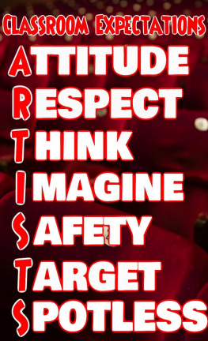

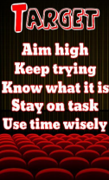

Play Report Requirement

The Play Report Requirement is your Final Exam grade and will be 10% of your final grade. Each drama class is required to complete "Play Report" assignments. Each student must complete, 2 outside of class, and 2 inside of the class during ‘Theatre Appreciation Friday’s’ for a total of 4. This page was designed to not only answer all questions about these reports but also as a resource for students to find ways to fulfill this requirement as well. Once students have seen a show, they must attach a ticket stub (preferred) or program to a Play Report sheet. Complete the form, and then turn in the form directly to me for credit. FAQ About this requirement…

- What kind of things count towards the required assignment?
A: Here is a list of some things that can count towards hours: seeing a play, seeing a musical, seeing a live orchestra concert (NOT a "rock" concert), seeing a choir perform, seeing a ballet, modern, or jazz dance group perform, seeing an improv group perform, being involved in any of those kinds of performances, attending acting classes (not drama class), attending improv workshops, attending dance classes, attending singing lessons, auditioning for a show, attending any special classes or workshops put on by the drama department that Mr. Fellers indicated will count towards hours.
- I'm not sure if an upcoming event will count towards hours, what do I do?
A: Before attending the event, bring any kind of literature, website, flyer, or anything about the event to Mr. Fellers for approval BEFORE you attend the event.
- I lost my ticket stub or program to attach as proof to my hours sheet. What do I do?
A: Take the form home and get a parent signature on the sheet. Have your parent sign, "Yes, (your name) did attend the following event" and their signature.
- Can I get extra credit if I do more than what is required?
A: There is no extra credit given for extra hours. However, if you are on a borderline grade (i.e. a B+ or a C+), I will bump you up to a higher grade (an A- or a B-) if you have extra hours. You must still turn in a form for those extra hours though!
- How much is this requirement worth?
A: It is 10% of your grade. This means that if you don't do any of the hours, your grade will drop an entire letter grade. So DO IT!!! This is the most popular way student do not pass my class!
- I know I'm going to have a hard time completing this. What should I do?
A: Please talk to me AT THE BEGINNING OF THE SEMESTER!!!! I will have no pity for you if you come to me a month before the requirement and tell me you can't do it. I have ways around the requirement if you have issues financially, transportation wise, with work, etc. However, I can only set this up if you talk to me at the beginning of the semester!
- Why do you make us do this requirement?
A: For multiple reasons. Mostly, I want to expose you to something you may have never been exposed to before. So many of my students come back from seeing a production inspired and even changed by what they've seen. School is supposed to open doors for you and let you experience the world. You never know what may end up happening when you go to see a show!
- I'm was in a production here at Ed White (i.e. the fall play, one-act, etc.). Do I still have to fill out a form?
A: Yes!!!!!
- When are hours due?
A: In my semester Beginning and Intermediate Theatre classes, they are due sometime during the last week of the semester. For Advanced Theatre, it’s the last week of the school year

Play Report Form 1
Return this form to me once you are finished. Please make sure you attach “proof” of seeing the show. Thank you!
Name: _________________________________
Period: _____
Title of the production: ____________________________________
Date you saw the production: ___________________
Please give a brief summary of the show you saw: (5 sentences please)

Please give a critique of the performance: (remember to look at ALL aspects of the production: acting, set, sound, lights, etc.) (5 sentences please)

Did you, or did you not enjoy the show that you saw? Please explain why. (3 sentences please)

Play Report Form 2
Return this form to me once you are finished. Please make sure you attach “proof” of seeing the show. Thank you!
Name: _________________________________
Period: _____
Title of the production: ____________________________________
Date you saw the production: ___________________
Please give a brief summary of the show you saw: (5 sentences please)

Please give a critique of the performance: (remember to look at ALL aspects of the production: acting, set, sound, lights, etc.) (5 sentences please)

Did you, or did you not enjoy the show that you saw? Please explain why. (3 sentences please)

Play Report Form 3
Return this form to me once you are finished. Please make sure you attach “proof” of seeing the show. Thank you!
Name: _________________________________
Period: _____
Title of the production: ____________________________________
Date you saw the production: ___________________
Please give a brief summary of the show you saw: (5 sentences please)

Please give a critique of the performance: (remember to look at ALL aspects of the production: acting, set, sound, lights, etc.) (5 sentences please)

Did you, or did you not enjoy the show that you saw? Please explain why. (3 sentences please)

Play Report Form 4
Return this form to me once you are finished. Please make sure you attach “proof” of seeing the show. Thank you!
Name: _________________________________
Period: _____
Title of the production: ____________________________________
Date you saw the production: ___________________
Please give a brief summary of the show you saw: (5 sentences please)

Please give a critique of the performance: (remember to look at ALL aspects of the production: acting, set, sound, lights, etc.) (5 sentences please)

Did you, or did you not enjoy the show that you saw? Please explain why. (3 sentences please)

Theatre Biography Report
Directions: You are to either check a book at one of the many libraries around town or find an article or webpage about two people in the film or theatre industry. It does not have to be just an actor. There are so many types of jobs in the entertainment industry that are not acting jobs. Once you have read the biography, fill out the two required worksheets. This worksheet will help you complete the final poster project.

Your worksheet will include the following:
- First and last name of the person
- A short summary of their early life.
- A life lesson you learned from this person’s story.
- One picture of the person.
- Why they are important.
- Their accomplishments.
- 2-3 interesting facts.
- One quote by or about that person
- Five words that describe this person.
- Bibliography

Theatre Biography Report grades will be 10% of your final grade. You will write and present a report on a past or current person who works in the film or theatre industry. I expect you to take your time and complete it carefully. There are also points for neatness and creativity.

Name of person: Name of Book (Bibliography):
Early Life:
_________________________________________________________________________________________________________________________________________________________________________________________________________________________________________________________________________________________________________________________________________________________________________________________________________________________________
Why they are important and what did they accomplish?
_________________________________________________________
_________________________________________________________
_________________________________________________________
_________________________________________________________
_________________________________________________________
_________________________________________________________
_________________________________________________________

1 to 2 Interesting Facts:
___________________________________________________________________________________________________________________________________________________________________________________________________________________________________________________________________________________________________________________________________________________________________________________________________________________________________________________

Picture

Picture and caption
Quote(s)

5 Adjectives to describe
A life lesson you learned from this person’s story.
___________________________________________________________________________________________________________________________________________________________________________________________________________________________________________________________________________________________________________________________________________________________________________________________________________________________________________________________________________________________

Early Life:
________________________________________________________________________________________________________________________________________________________________________________________________________________________________________________________________________________________________________________________________________________________________________________________________________________________________
Name of person: Name of Book (Bibliography):

Why they are important and what did they accomplish?
_________________________________________________________
_________________________________________________________
_________________________________________________________
_________________________________________________________
_________________________________________________________
_________________________________________________________
_________________________________________________________

1 to 2 Interesting Facts:
___________________________________________________________________________________________________________________________________________________________________________________________________________________________________________________________________________________________________________________________________________________________________________________________________________________________________________________

Quote

Picture

Picture and caption

A life lesson you learned from this person’s story.
___________________________________________________________________________________________________________________________________________________________________________________________________________________________________________________________________________________________________________________________________________________________________________________________________________________________________________________________________________________________
5 Adjectives to describe

Theatre Arts Department Course
Selections and Requirements
Beginning Level Theatre Classes

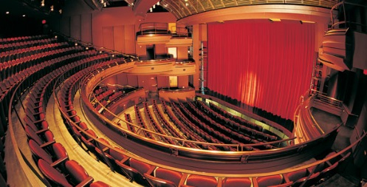
6th Grade Beginning Theatre I Course 0350

Prerequisites: Interest from student. No recommendation required from theatre teacher. This class cannot be repeated by former students.

Description: This semester long, introductory level course that allows the student to study the various aspects of theatre such as acting, pantomime, improvisation, public speaking, play analysis and play production, as well as theatre history. Members of this class are encouraged to participate in either the Fall or Spring N.E.I.S.D. Speech & Theatre contests. Memorization is a requirement in class.

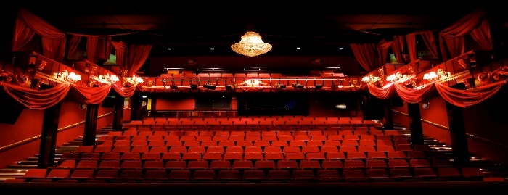
7th and 8th Grade Technical Theatre I Course 0350A

Prerequisites: Interest from student. No recommendation required from theatre teacher. This class cannot be repeated by former students. This is for beginners who did not take 6th Grade Beginning Theatre I.

Description: This is a full year long, introductory level course that provides an opportunity for novice students to explore technical non-acting side of the Theatre. The course focuses on beginning stage craft techniques that are the foundation for technical theatre. The beginning technicians will learn to interpret and execute a theatrical designer's plans, much like a beginning actor learns how to interpret and execute a playwright's script. Through projects and work on Mainstage productions, students gain the confidence and technique needed to become a skilled technician. Each student is required to participate in a minimum of one production each semester.

Advanced Level Theatre Classes
Advanced Level Theatre Arts Classes (Teacher Signature Needed)

7th Grade Advanced Theatre I
Course 0352A

Prerequisites: The student must have either taken 6th, 7th, or 8th Grade Beginning Level Theatre I. Student must have my recommendation and sign a contract. Student must have my recommendation and sign a contract.

Description: This semester long, performance-oriented course that provides the student opportunities to experience more detailed theatrical studies and encourages personal development of performance skills through a variety of speaking/acting situations. Activities include improvisation/acting, clowning/pantomime, and tech theatre. Members of this class are required to participate in BOTH the Fall or Spring N.E.I.S.D. Speech & Theatre contests. Each student is to participate in a minimum of three events. Students will participate in two play productions. Memorization is a requirement in class.

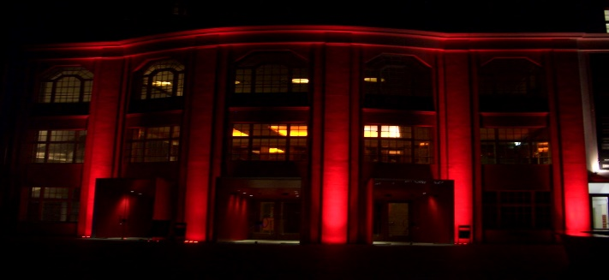
8th Grade Advanced Theatre II
Course 0354A

Prerequisites: The student must have either taken 6th, 7th, or 8th Grade Advanced Level Theatre II, as well as have participated in Speech competitions or a play production. Student must have my recommendation and sign a contract. Student must have my recommendation and sign a contract.

Description: This full-year, performance-oriented course engages the student in advanced theatrical studies and provides numerous performance opportunities. Classroom activities include advanced acting techniques and character study, improvisation, pantomime, play analysis, audition techniques, elements of play production, and technical theatre. Advanced Theatre II will begin the year with a class play performance involving all enrolled students. Members of this class are required to participate in the N.E.I.S.D. UIL One Act Play contest as well as several play productions. These students will be the "face" of our school and should behave as leaders. Students must be passing at the end of every 9 weeks to stay in the class. Failure to do so will result in the student being removed from the program. Memorization is a requirement in class.

Grading Policy Theatre Arts
Warm-Ups will be 10% of your final grade. Game participation and exercises: vocal, physical, and mental.
Discussions will be 15% of your final grade. Conversations, opinions, and thoughts on various theatre or life-related topics.
Assignments will be 20% of your final grade. Your daily grade will be comprised of documents, forms, sheets, and slides.
Quizzes will be 15% of your final grade. Mini-assessments testing pre and post knowledge.
Tests will be 20% of your final grade. End of unit grades to assess knowledge and skill in Theatre. Biography and Play Reports fall under this category.
Performances will be 20% of your final grade. Also, in this category is audience etiquette and performance critiques count towards your test average.
As you can see, students are graded on various ways of expression, memorization, etc. I like to see strong body language, good enunciation, projection, and delivery of lines. They must also memorize scenes for the most part in this class. You will pass by using all in-class time to rehearse, staying with your partner and not sidetracking others, and improving on your performances. I’m a firm believer that it’s not the destination that’s important but the journey in this class. How students use their class time is essential.

Missing a Performance Policy
(This policy is the same for Beginning, Intermediate, and Advanced Theatre Arts)
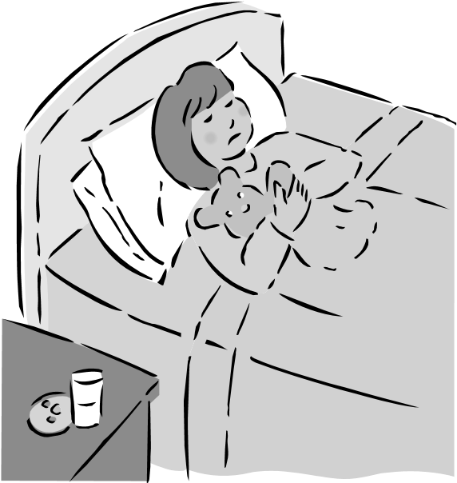
Things happen. Students get sick. I understand. However, if you are absent on a performance day, there is a specific procedure that must be followed. If a student has an excused absence on the day of a performance, he or she must first clear the absence with me THAT DAY.
An e‐mail, text, or telephone call from the parent must happen THE MORNING OF THE PEROFRMANCE. We will need to inform the school Principal, Fine Arts Department Head, and parents of other students that we need to reschedule the show. We will need to inform the district as well. Then I need to sit down with the Principal and Department Head in order to see when we can reschedule our show. I want you to understand thought that the first rule in Theatre is, “The Show Must Go On!” Here is a list of reasons that I will not find acceptable when calling in during a performance date…
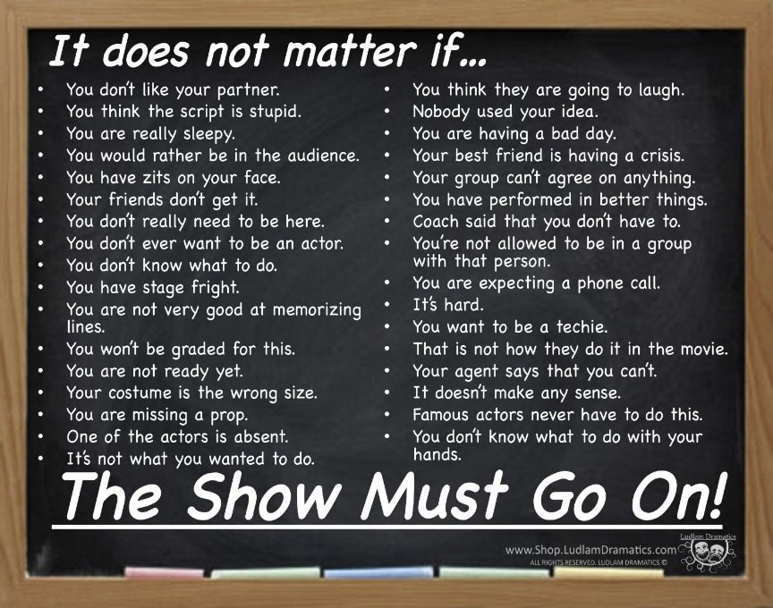
Mr. Fellers’ Pet Peeves
Mr. Fellers has a few pet peeves! Don’t do these!

1. Not working when given rehearsal time
Guess what I want you to do when you are given time to work in class. . . .REHEARSE! It’s not social hour. It’s work time!

2. Being absent all the time
Being absent constantly keeps you and us from mounting a show that we and the community can all be proud of. If you are contagious, then please, by all means stay home. We don’t want to spread anything around campus. If you are staying home because you stayed up late and didn’t get enough sleep, that’s no excuse. Make sure to get a full 8 hours of sleep. Death in the family? Those are difficult and hard times, and completely understandable. If you have a vacation planned and will be out of town for a week or more, you need to inform me ahead of time.

3. A negative attitude and not having an open mind
Give new things a chance in this class. Make the most out of every opportunity you are given. If you can’t commit, then quit!

4. Not following through for your group members
If you say you are going to do something, then do it. If you are going to commit to this Department, then I want 100% and nothing less! It’s rude and unprofessional if you don’t. Save the private life for later.

Contracts and Agreements
Behavioral Contract for Theatre Arts/Broadcast Journalism
By remaining in the class and not getting a schedule change, the student agrees to be on his/her best behavior and have a good attitude while in Theatre Arts or any Elective. The student agrees to follow every instruction that the teacher gives them without unnecessarily questioning the teacher's authority, or complaining while the teacher is trying to run a smooth class. In case the student is unable to fulfill the instructions of the teacher which are for the good of the student, then the teacher has the right to give them further consequences.
The student is further reminded of the Student Code of Conduct concerning their participation in ANY Elective…
“EXTRACURRICULAR ACTIVITIES”

The opportunity to participate in extracurricular activities is a privilege extended to all students of NEISD. Participation in extracurricular activities places students in a position of recognition and often bestows the position of role model upon the student participants. Students who elect to accept the privilege of participating in extracurricular activities must recognize that they are a representative of the school and District, and will be held to a higher standard of conduct than that applied to other students. This applies to both school related and non-school related activities.”
If the student was placed in the class without any choice in the matter, the student is being reminded again that they are still held to all the expectations and standards set forth in the class. The student was informed at the beginning of the semester that if the class was not for them, that they needed to get a schedule change. It is not the responsibility of the teacher to do that for them.
Theatre Arts/Broadcast Journalism Pledge for
Students and Parents
I pledge the following:

- I will be a team player: My role is important to the class and it is important to me. Just as I want my ideas heard and worked with by my teammates, I will listen to them and support their ideas in a POSITIVE way. I will NOT any anyway bring a negative attitude, or use negative words towards my fellow teammates.

- I will be flexible and open-minded: I will do my best to put aside my insecurities to take advantage of ALL of the opportunities that are given to me to improve myself so as to become a better citizen for my community, state, country, and the world.

- I will be both focused and energetic: It may seem like focus and energy are opposites, but sports teams (for example) use focused energy all the time. I can be focused without being low-energy, and I can be energetic without bouncing off the walls!

- Please, No Pickles: Please know that tardiness, absences, and not learning lines leave the class in a PICKLE. We work as a team (an ensemble) and if one of our team members is missing or behind on lines, our progress is challenged! I will be on time and prepared for anything that comes my way in class.

EXPECTATIONS FOR THEATRE ARTS
What I Expect From My Students

I expect the following things:

1. To get an education and not be a disruption in ALL my classes.
2. Pass every class.
3. To hustle 100% at all times.
4. To give unselfish love towards your classmates and to respect them. Before you can love and respect somebody else, you must love and respect yourself.
5. Practice to the best of your ability.
6. To be totally honest in all your dealings.
7. To be extremely loyal to your school, administration, teammates, coaches, families and friends.
8. To work hard to the maximum, of your potential at all times, practice and games. This includes sprints.
9. To be prompt for all meetings and practices.
10. Never take an opportunity to criticize and never pass up one to praise.
11. To be a part of something great.
12. To be a winner and a leader for our campus.

What You Can Expect From Me the Teacher

You can expect the following things:

1. To be loyal to you in all areas.
2. To be totally honest.
3. To provide the leadership and training necessary to achieve our goals.
4. To work you harder than you have ever worked before.
5. To assist you in any way possible now and after you graduate.
6. To treat you with respect as you do me.
7. To make all decisions predicated on what is best for the team and then what is best for the individual.
8. To do everything within our power to improve our facilities and make this the best place in Texas to go to school and learn Theatre.
9. To help you mature and grow as a person.
10. To help you reach your goals.

Production Policies and Rehearsal Rules Contract

Production Rules

- The Director is in charge of ALL aspects of the show. DO NOT help to direct unless you’re asked. Do not tell another actor how to do his/her part, and don’t ask ANYONE BUT THE DIRECTOR how to do yours.

- The cast is expected to follow the Assistant Director and the Stage Manager’s orders quickly, knowing he/she is carrying out the wishes of the Director.

- PERFOMANCE NIGHTS. DO NOT be seen by the audience BEFORE the show, and DO NOT come out to greet them AFTER the show until you have gotten permission from the director, assistant director, or stage manager.

Rehearsal Rules

- ALL CASTING IS NOT PERMANENT!!! If at any time it’s evident an actor would do better in another role, roles will be changed, or if they are not following the terms of the contract they can and will be replace altogether.

- BRING YOUR SCRIPT AND A PENCIL TO EVERY REHEARSAL!

- ALWAYS be on time. If there is a good reason you can’t be, let the DIRECTOR, ASSISTANT DIRECTOR, or STAGE MANAGER know before rehearsal, so we can adjust our plans. You must also inform the DIRECTOR, ASSISTANT DIRECTOR, or STAGE MANAGER when you have to leave early before rehearsal begins. Otherwise, you will be expected to stay until rehearsal time is over.

- If you are ABSENT WITHOUT PERMISSION TWICE, you’ll be dismissed from the show. The absence must be excused by the director.

- We conduct CLOSED rehearsals. This means that your friends or parents cannot hang out while we practice. NO ONE may visit without prior permission.

- DO NOT leave the theatre FOR ANY REASON without asking the DIRECTOR, ASSISTANT DIRECTOR, or STAGE MANAGER.

- Use any waiting time to study lines or to develop your character. Make plans to bring books, homework or video games/ipod to have quiet play at this time

- Be courteous to those on-stage by being VERY QUIET.

- DO NOT talk whenever the Director, Assistant Director, or Stage Manager is speaking. Besides distracting others, YOU may miss something you need to know.

- Cell phones or electronic devices are not allowed during rehearsal unless you have special permission from the DIRECTOR.

- Walk on TIPTOE backstage, and DO NOT TALK backstage during performances or rehearsals. EVERY SOUND CAN BE HEARD BY THE AUDIENCE.

- You will help keep every space that we used cleaned after we are done.

Failure to follow any or all of the above policies or rules can result in a student being replaced. The contract must be signed and turned in before a student can accept a role. Failure to sign and turn in the contract means the role will be offered to another student. You must agree to all of the terms of the contract in order to participate in a production.

Permission to View Film/Video for Theatre Arts

Dear Parents or Guardians,

Our school requires parental permission for your student to view movies that are used in our curriculum, or that are selected by our teachers that are rated above G. I am notifying you that we will be watching films/videos in class with a rating G and PG. In 8th and 7th grade PG-13. I will be showing these films/videos in the classroom throughout the year. Occasionally, films/videos are used in the classroom in order to illustrate a particular curricular-related concept. This is especially true in a Theatre Arts Class.
Movies, along with our hands-on activities such as reading, in-class discussion groups, and research projects, give students a well-rounded opportunity to discover the world of Theatre and History. Live performances and movies go beyond dry facts and help bring events and experiences “alive.”
Be assured that I will use proper discretion when showing full-length movies.
Instructional objectives:

Students increase their understanding of heritage and traditions through historical and cultural studies in theatre. Student response and evaluation promote thinking and further discriminating judgment, developing students who are appreciative and evaluative consumers of live theatre, film, television, and other technologies.

Response/evaluation. The student responds to and evaluates theatre and theatrical performances. The student is expected to:
(A) identify and demonstrate appropriate audience behavior at various types of performances;
(B) evaluate the effectiveness of selected film and television performances;
(C) identify visual, aural, oral, and kinetic components in art, dance, music, and theatre; compare and contrast the presentation of the same subject in art, dance, music, and theatre; and create improvisations, integrating art, dance, and/or music to express ideas and emotions; and
(D) compare career and avocational opportunities in theatre.

Historical/cultural heritage. The student relates theatre to history, society, and culture. The student is expected to:

(A) demonstrate knowledge of theatre as a reflection of life in particular times, places, and cultures; and
(B) define theatre heritage as it is preserved in dramatic text, traditions, and conventions and describe the roles of theatre, film, television, and electronic media in American society.

Beginning Theatre Play Selections Advanced Theatre I
Shrek the Musical The Phantom of the Opera
Peter Pan the Musical Love Never Dies (Sequel to the Phantom of the Opera)
The Wiz Live Driving Miss Daisy
Sponge Bob the Musical The Sound of Music Live

NEISD Fine Arts Code of Conduct
Revised 7/2020

North East ISD offers all students the opportunity to participate in a wide variety of extracurricular activities including band, orchestra, choir, theatre, spirit, clubs and organizations. Participation is encouraged as a portion of the 360-degree North East ISD educational experience to develop skills and knowledge in addition to academics.

Regulations have been established to promote appropriate behavior of the students representing the schools through their leadership roles and participation in Fine Arts extracurricular activities, which are a privilege and not a right. Students participating in these extracurricular activities are deemed to represent their respective school at all times, whether on or off school grounds. For this reason, the expectations for students involved in Fine Arts extracurricular activities exceed the expectations for the general student body. Students participating in Fine Arts extracurricular activities are expected to follow the District’s Student Code of Conduct, the Fine Arts Code of Conduct and any constitution and/or handbooks of the specific extracurricular organization in which they participate. The expectations for each specific extracurricular organization will be developed and approved by the campus director/coach, campus principal and Fine Arts director. Violations of the applicable rules will result in corrective and/or disciplinary action. Such corrective and/or disciplinary actions for rule violations will be imposed based upon the facts and circumstances revealed through investigation or review of the alleged infraction(s).

Please read the NEISD Fine Arts Code of Conduct carefully. Administrators, the Fine Arts Department and the Fine Arts directors/coaches developed these guidelines. After reading this document, it is necessary that you and your parent/guardian sign all appropriate places and return a signed copy to the director/coach of the program in which you plan to participate. It is suggested that you keep a copy at home for reference.

STUDENT BEHAVIOR GOALS

- All Fine Arts extracurricular students are to conduct themselves properly and should always show respect to their administrators, teachers, coaches and fellow students.
- Fine Arts extracurricular students are to display and model the positive behaviors associated with good citizenship both at school and in the community.
- Fine Arts extracurricular students are to serve as positive representatives for their programs, schools and North East ISD during competition, interactions with other districts’ programs and at all other times. 4. Fine Arts extracurricular students are to strive for academic excellence and to adhere to the campus handbooks/constitutions for their specific campus and extracurricular activity, Student Code of Conduct and the Fine Arts Code of Conduct.

STUDENT GROOMING AND APPEARANCE

Regulations are established to promote and establish a positive and uniform appearance of Fine Arts extracurricular students representing the program in performance and competition. It is recognized that some expectations for Fine Arts extracurricular students may exceed the expectations for the general student body. Full compliance with the North East Student Handbook dress code is expected and will be enforced. Students in Fine Arts extracurricular activities must adhere to the expected appearance and grooming guidelines set forth by their specific extracurricular activity, to include the use of uniforms.

Consequences

The use, possession or distribution of illegal or controlled substances or involvement in other violations of the Student Code of Conduct will be addressed with disciplinary actions by the Fine Arts extracurricular activity director/coach in addition to any disciplinary actions taken by the school, District or law enforcement agency. The student alleged to be involved in a violation will be provided an opportunity to address the allegations. An investigation will be completed prior to a decision being made regarding the allegations. Any student involved in Fine Arts extracurricular activities found to be in violation of the aforementioned rules will face disciplinary action regardless of the time or place of the violation. This includes on campus, off campus and the internet/social media.

Once the determination has been made that a violation occurred, the general guidelines for student discipline as outlined in the North East ISD Board Policy FO (Local) will be used, when possible, and applied to all cases concerning the District’s Fine Arts Code of Conduct. The following disciplinary actions will be administered throughout the District when infractions occur including, but not limited to: drugs, alcohol, tobacco, hazing, felony with bodily harm, conviction of a felony, nudity or promotion of pornography, to include “sexting” activities as discussed more fully below.

Following an offense, a formal conference will be conducted involving the student, parent/guardian, Fine Arts director/coach and campus administrator. A written and signed notice of the conference will be provided to the parent and student. Length of suspension from participation in an extracurricular activity will be determined by the following in alignment with the NEISD Student Code of Conduct.

CATEGORY I OFFENSES- MANDATORY EXPULSIONS (Texas Education Code Section 37.007) Students SHALL BE expelled and referred to the Juvenile Justice Academy (JJA) for any of the offenses listed in the Student/Parent Handbook under category I offenses, if committed on school property or while attending a school sponsored or school-related activity on or off school property:

- Category I Offense: Minimum suspension for the remainder of the school year up to permanent removal. The student may not participate in the extracurricular activity anytime during the suspension period.

CATEGORY II OFFENSES- Students SHALL BE placed in a disciplinary alternative education placement (DAEP) or MAY BE expelled and referred to the Juvenile Justice Academy (JJA) for offenses listed in the Student/Parent Handbook under category II offenses.

CATEGORY III OFFENSES- Except as provided by Texas Education Code Section 37.007 (a)(3), students SHALL BE removed from class and placed in a DAEP, as provided by Texas Education Code Section 37.006 for offenses listed in the Student/Parent Handbook under category III offenses.

- Category II &III Offens: (First offense) Minimum 9 weeks (45 school days) suspension up to removal for the remainder of the school year. This suspension begins after the student returns from the DAEP placement; this time is not concurrent. The student may not participate in the extracurricular activity anytime during the
suspension period.
- (Second offense) Minimum 18 weeks (90 school days) suspension up to permanent removal. This suspension begins after the student returns from the DAEP placement; this time is not concurrent. The student may not participate in the extracurricular activity anytime during the suspension period.

CATEGORY IV OFFENSES- Students MAY BE placed in a DAEP for offenses while on school property, at any school facility, at any school sponsored or school-related activity, or on a school bus for offenses listed in the Student/Parent Handbook under category IV offenses.

- Category IV Offense: (First offense) Minimum 3 week (15 school day) suspension up to removal for the remainder of the school year. This suspension begins after the student completes their discipline assigned by the campus; this time is not concurrent. The student may not participate in the extracurricular activity anytime during the suspension period. (Second offense) Minimum 6 week (30 school day) suspension up to permanent removal. This suspension begins after the students completes their discipline assigned by the campus; this time is not concurrent.
- The student may not participate in the extracurricular activity anytime during the suspension period. Suspensions also include any extracurricular activities/events occurring over a weekend. Students may not participate in extracurricular activities while serving their campus assigned discipline consequence.

UNACCEPTABLE AND INAPPROPRIATE USE OF TECHNOLOGY RESOURCES: Students are prohibited from possessing, sending, forwarding, posting, accessing, or displaying electronic messages that are abusive, obscene, sexually oriented, threatening, harassing, damaging to another’s reputation, or illegal. This prohibition also applies to conduct off school property, whether the equipment used to send such messages is district-owned or personally owned, if it results in a substantial disruption to the educational environment. Any person taking, disseminating, transferring, possessing, or sharing obscene, sexually oriented, lewd, or otherwise illegal images or other content, commonly referred to as “sexting,” will be disciplined according to the Student Code of Conduct, may be required to complete an educational program related to the dangers of this type of behavior, and, in certain circumstances, may be reported to law enforcement. Because engaging in this type of behavior can lead to bullying or harassment, as well as possibly impede future endeavors of a student, we encourage you to review with your child the information presented on the following website: http://beforeyoutext.com, a state-developed program that addresses the consequences of engaging in inappropriate behavior using technology. In addition, any student who engages in conduct that results in a breach of the district’s computer security will be disciplined in accordance with the Student Code of Conduct, and, in some cases, the consequence may rise to the level of expulsion from the District.

CONSEQUENCE: At a minimum a conference with student and parent/guardian up to removal for the remainder of the school year, depending on the severity of the infraction. This suspension begins after the student completes their discipline assigned by the campus; this time is not concurrent. The student may not participate in the extracurricular activity anytime during the suspension period.

The discipline consequences for violation of the Fine Arts Code of Conduct may include suspension or dismissal from the extracurricular program. Such actions, if any, shall be taken by the directors/coaches of the extracurricular activity only after consultation with school administration. A behavior conference may also be used following any rule infractions. Consequences for some rule infractions may be addressed by the director through discipline within the student’s Fine Arts program (i.e. reduced performance time, role or position reassignments, contracts, etc.). Additional disciplinary consequences can also be imposed by the appropriate school officials for conduct or behavior that violates the District’s Code of Student Conduct. NOTE: If the offense occurs during the summer, the suspension will begin with the first week of school. If the offense occurs at the end of the year, the remaining suspension will carry over to the next year in which the student participates.

Student Leadership

Students in leadership positions and students who participate in extracurricular activities, on or off campus and on the internet/social media, are subject at all times to school district policy, including this Code, and UIL rules. The student’s privilege of participation in these activities may be revoked, suspended, or otherwise adversely affected at any time when:

- The director/coach of an extracurricular activity or a campus administrator determines that the student’s conduct has an incidental or direct negative effect on the student’s team or activity, school campus or school district; and/or
- The director/coach of an extracurricular activity or a campus administrator determines that the student’s conduct warrants the revocation of the student’s leadership role, as a disciplinary measure; and/or 3. the director/coach of an extracurricular activity or a campus administrator determines that the student’s conduct warrants the revocation or suspension of the student’s extracurricular activities as a disciplinary measure

TERMINOLOGY

Suspension/Probation – removal from performance. Students will continue to practice/rehearse unless otherwise determined by the director/instructor.

Removal — refers to taking a student out of the Fine Arts program. Removal is generally intended to be for the length of an expulsion, for one year, or for the remainder of the student’s career.

Behavior Conference — a conference conducted between the student in question, the student’s parent/guardian and the campus administrator. It is to be documented and placed in the student’s file.
Consequences – may range from a warning, to a conference, to conditioning drills, Level I or Level II ISS (In School Suspension), DAEP (Disciplinary Alternative Education Program) assignment, expulsion, removal for a period of time or removal for the remainder of the student’s career may also be assessed by an administrator as a consequence. (ISS LEVEL ONE or LEVEL TWO – Students may practice but not participate in performances until school is out on the last day of stay in ISS.

Length of penalties — penalties that involve suspension of days will require that the days run consecutively as calendar days beginning with the first day the violation is reported and continue until school is out on the last day of the penalty.

Carryover penalties — penalties that occur late in the school year or at a time such that the days cannot be served prior to the end of school will carry over to the next school year.

ALL APPEALS BY A STUDENT OF CONSEQUENCES OR DECISIONS DESCRIBED IN THE FINE ARTS CODE OF CONDUCT WILL FOLLOW NORMAL NEISD GUIDELINES AS DESCRIBED IN SCHOOL BOARD POLICY FNG (LOCAL).

Student-Parent Fine Arts Code of Conduct Acknowledgment Form (See page 29)

North East Independent School District officially adopted a District Behavior Management Plan including a Fine Arts Code of Conduct that promotes a positive and constructive approach to the improvement of learning situations and the overall school environment. It was developed through the commitment, cooperation, and involvement of the District’s administrators, teachers, parents/guardians, and students in keeping with the guidelines of the Texas Education Code. The Fine Arts Code of Conduct is intended to serve as a resource to students, parents/guardians, and staff. This document defines rights and responsibilities of each participant in Fine Arts extracurricular activities and provides general information regarding District policies, practices, and procedures. The Fine Arts Code of Conduct is not an all-inclusive document and may be altered periodically.

Please review this information so that there is a shared understanding of the District's expectations for student behavior and resulting consequences, as well as, the general practices of the District/Fine Arts Department. If you have any questions relating to the Fine Arts Code of Conduct, please contact your child’s director/coach.

I reserve the right to alter the syllabus for this class should it be necessary. Any changes will be fully explained to the parents and students.
Student Handbook VERIFICATION Form

I have read and reviewed the following (Please check off each box to double check)…

- Theatre Arts/Broadcast Journalism Student/Parent Handbook (pages 1-21)
- Behavioral Contract for Theatre Arts/Broadcast Journalism (page 22)
- Theatre Arts/Broadcast Journalism Pledge for Students and Parents (page 22)
- EXPECTATIONS FOR THEATRE ARTS/BROADCAST JOUNALISM (page 23)
- Production Policies and Rehearsal Rules Contract (page 24)
- NEISD Fine Arts Code of Conduct Student (pages 26-28)

I understand the expectations and rules for the Theatre Arts Department, Ed White, and NEISD. Our signatures indicate that we have reviewed and discussed the handbook together, that we will commit and support the Ed White Middle School Theatre Arts Program, and do what is necessary to insure the success of the Theatre Arts Department. We are also aware that positive and proactive behavior is a MUST for our program and school and agree to back-up all efforts to keep our school and department safe and orderly. I understand that I/my child will be responsible or adhering to the rules and procedures as outlined in this document. I am aware of the responsibility for reading and understanding the contents of the document.

Student Name (please print) ___________________________________________________________Grade _____________

School ____________________________________________________________________ Date________________________

Student Signature ______________________________________________________________________________________

Parent/Guardian Signature ______________________________________________________________________________
---------------------------------------------------------------------------------------------------------------------------------------
- Permission to View Film/Video for Theatre Arts/Broadcast Journalism (page 25)

____ Yes, I give my son/daughter permission to view curriculum and school appropriate film/videos related to classroom content and subjects.

____ No, I do not give my son/daughter permission to view curriculum and school appropriate film/videos mentioned in this letter. I understand alternate learning experiences will be provided for my child while the movie is being watched.

Signature of Parent/Guardian:____________________________________________________________________________
---------------------------------------------------------------------------------------------------------------------------------------
- Student Media Release Form (page 29)

Student Name (please print):____________________________________________________ Grade Level:_____________

Has my permission Does not have my permission

To be interviewed, photographed, and/or filmed for public information for us in the news media or professional education information.

Campus: ________________________________ Date:__________________

Address: _______________________________________________________________________________________________

Parent/Guardian Signature:_________________________________________________________________________________

Comments:

